Production System Startup Using the SysMan Console

Thursday, March 08, 2001

Table of Contents

Introduction 1
Prerequisite Processes 1
Starting Prerequisite Processes via Telnet Session 1
Process Startup Order 2
Enable SysManAgent Mbean Locator see Appendix C 3
Appendix A 5
Application Startup 5
Starting Fundamental Trade Server Processes 5
Start the ID Server 5
Start the User Session Management Server 5
Start the Global Server 6
Start the Trade Server 6
Starting the External Integration Services 7
Appendix B Master/Slave Switching 11
Part 1 Application Processes 11
Part 2 Infrastructure Processes 13
Appendix C 15
Enable SysManAgent Mbean Locator 15
Appendix D 16
Initial Console Startup 16
Appendix E 19
Starting Processes from the SysMan Console 19
Appendix F 21
Shutting Down a Server 21

Introduction

This document describes the SBT system startup procedures using the SysMan console.

Prerequisite Processes

The following infrastructure Java processes must be running prior to using the SysMan console
On prdgc0a1 and prdgc01b the following processes should be running
Process Type Process Name

Primary SysManAgent ProdSysManAgent1(hostName)
Backup SysManAgent ProdSysManAgent2(hostName)
LocatorServer ProdLocatorServer(A/B)

On prdgc0a1 or prdgc01b the following process should be running
Process Type Process Name
CentralRepository ProdCentralRepository

On prdbc0a1 and prdgc01b the following process should be running
Process Type Process Name
Primary SysManAgent ProdSysManAgent1(hostName)
Backup SysManAgent ProdSysManAgent2(hostName

On prdfe01 and prdfe02 the following process should be running
Process Type Process Name
Primary SysManAgent ProdSysManAgent1(hostName)
Backup SysManAgent ProdSysManAgent2(hostName

These process can only be started via the Patrol console or through the command line

Starting Prerequisite Processes via Telnet Session

Telnet to the desired system, log in with a valid operator log in. Doing this will execute the necessary scripts to establish a proper environment. Part of this setup is the $RUN_DIR variable. All startup scripts assume execution from the ‘Running Directory’ in $RUN_DIR. These processes must be started in the order listed.

Start the LocatorServer

From the Telnet window
cd $RUN_DIR
startLocator

Start the CentralRepository

From the Telnet window
cd $RUN_DIR
startSysManRepository

Start the SysMan Agent

IMPORTANT NOTE – When starting the agent on the first server in the complex, the –m parameter will be ignored until ALL the infrastructure components have been started.

Once ALL the infrastructure components have been started, re-issue the startSysManAgent command with the –m parameter. If the –m is either ignored or omitted, the agents will not be able to communicate to each other and will result in unpredictable results when starting the other servers.

From the Telnet window
cd $RUN_DIR
startSysManAgent -m

Start the SysMan Console
See Appendix D

Server Startup Order
Server startup is done in the following order – Primary Global cluster, Backup Global cluster, Primary Business cluster, Backup Business cluster, FrontEnd1, FrontEnd2, CAS1-n.

Procedures for starting processes via the SysMan console
See Appendix E

Process Startup Order

Primary Global Server

Infrastructure Processes

TraderServiceA
InterfaceRepositoryA
SecurityServiceA
ChannelAdminA
Guardian1A<hostname>
DN1A<hostname>
LiteMultiTraderA
LiteMultiSecurityA
CentralLoggingA
TimeServiceA
CalendarServiceA
SecurityAdminServiceA
CollectCommPathMeters
TranTimingRegistration
TranTimingConsumer

Server Processes

NOTE-See Appendix A for additional startup procedures. Primary Server processes need to be transitioned to Master manually.

IDServer<hostname>
SMSServer<hostname>
Frontend<hostname>
TipsAdapter<hostname>
TpfGlobal<hostname>
MemAdapter<hostname>

Enable SysManAgent Mbean Locator see Appendix C

Secondary Global Server

Infrastructure Processes

TraderServiceB
InterfaceRepositoryB
SecurityServiceB
ChannelAdminB
Guardian1B<hostname>
DN1B<hostname>
LiteMultiTraderB
LiteMultiSecurityB
CentralLoggingB
TimeServiceB
CalendarServiceB
SecurityAdminServiceB

Server Processes

NOTE-See Appendix A for additional startup procedures

IDServer<hostname>
SMSServer<hostname>
Frontend<hostname>
TipsAdapter<hostname>
TpfGlobal<hostname>
MemAdapter<hostname>

Business Server Primary

DN1A<hostname>

NOTE-See Appendix A for additional startup procedures. Primary Server processes need to be transitioned to Master manually

TradeServer1<hostname>
ExtTradeServer1<hostname>
TpfAdapter<hostname>
CtmAdapter<hostname>

Business Server Secondary

DN1B<hostname>

NOTE-See Appendix A for additional startup procedures

TradeServer1<hostname>
ExtTradeServer1<hostname>
TpfAdapter<hostname>
CtmAdapter<hostname>

Frontend Server(s)

TraderServiceProxy
InterfaceRepositoryProxy
SecurityServiceProxy
ChannelAdminProxy
DN1A<hostname>
CentralLoggingProxy
SecurityAdminServiceProxy

NOTE-See Appendix A for additional startup procedures

SMSServerProxy
Frontend<hostname>

Appendix A

Application Startup

Prior to Starting the Application

Clean Logs & Trade Data

Clean up server-related log files by executing the command “rmlogs”.

From the Telnet window
cd $RUN_DIR
cd log
rmlogs

Starting Fundamental Trade Server Processes

NOTE-Server processes will default to slave mode on startup. The status indicator will be set to Initializing and the console will indicate Yellow during initial startup. When the status indicates Slave the process is up and ready to be transitioned.

Starting the application processes is the same as starting the infrastructure. The difference is that although the status turns green fairly quickly, this does not mean that the process has actually been started: it simply “kicked off” the process.

Start the ID Server

From the SysMan console

Invoke the Startup command on the IdServer process. Wait until the process turns green.

From the SysMan console make sure the IdServer is fully up

Expand the IdServer process by clicking on the + to the left of the process node.
Find the IdServer:GlobalFoundationFramework_0 node and expand it.
Click on IdServer:GlobalFoundationFramework_0.FoundationFramework _IdServer node
Change to the properties tab.
Wait for the state to indicate Slave

Start the User Session Management Server

From the SysMan Console

Invoke the Startup command on the SMSServer process. Wait until the process turns green.

From the SysMan Console make sure the SMSServer is fully up

Expand the SMSServer process by clicking on the + to the left of the process node.
Find the SMSServer:GlobalFoundationFramework_0 node and expand it.
Click on SMSServer:GlobalFoundationFramework_0.FoundationFramework _SMSServer node
Change to the properties tab.
Wait for the state to indicate Slave

Start the Global Server

From the SysMan Console

Invoke the Startup command on the Global process. Wait until the process turns green.

From the SysMan Console make sure the Global Server is fully up.

Expand the GlobalServer process by clicking on the + to the left of the process node.
Find the GlobalServer:GlobalFoundationFramework_0 node and expand it.
Click on GlobalServer:GlobalFoundationFramework_0.FoundationFramework _GlobalServer node
Change to the properties tab.
Wait for the state to indicate Slave

Start the Trade Server

From the SysMan Console

Invoke the Startup command on the TradeServer1 process. Wait until the process turns green.

From the SysMan Console make sure the TradeServer is fully up

Expand the TradeServer1 process by clicking on the + to the left of the process node.
Find the TradeServer:GlobalFoundationFramework_0 node and expand it.
Click on TradeServer:GlobalFoundationFramework_0.FoundationFramework _TradeServer node
Change to the properties tab.
Wait for the state to indicate Slave

Starting the External Integration Services

This section describes starting the various external integration services that are available.
Normally, only the “TpfAdapter” process would be required. All external integration servers provide several services that need to be explicitely started after the server is running, as described in the “starting services subsections for each adapter listed below. All services below require that the processes described above (Global, Trade, SMS, and Frontend) be running.

TIPS Adapter

The TIPS adapter process provides a connection to three TIPS services.

From the SysMan Console

Invoke the Startup command on the TipsAdapter process. Wait until the process turns green.

From the SysMan Console make sure the TipsAdapter is fully up

Expand the TipsAdapter process by clicking on the + to the left of the process node.
Find the TipsAdapter:GlobalFoundationFramework_0 node and expand it.
Click on TipsAdapter:GlobalFoundationFramework_0.FoundationFramework _ TipsAdapter node
Change to the properties tab.
Wait for the state to indicate Slave

Starting Tips Services From the SysMan Console

NOTE- The process must be master before doing this. See Appendix A for instructions on how to make a process Master.

Expand the TipsAdapter process by clicking on the + to the left of the process node.
Find the TipsConnectionService:GlobalConnectionService_0 node and expand it.
Click on the TipsConnectionService:GlobalConnectionService _0.ConnectionServiceHomeImpl node. Change to the methods tab
Invoke the StartAllServices command.

From the Telnet window

cd $RUN_DIR
cd log
connectionStatus Tips

TPF Adapter

The TPF adapter provides some services from the TPF system. The TPFGlobal adapter provides another complimentary set of services.

From the SysMan Console

Invoke the Startup command on the TpfAdapter process. Wait until the process turns green.

From the SysMan console make sure the TpfAdapter is fully up

Expand the TpfAdapter process by clicking on the + to the left of the process node.
Find the TpfAdapter:GlobalFoundationFramework_0 node and expand it.
Click on TpfAdapter:GlobalFoundationFramework_0.FoundationFramework _ TpfAdapter node
Change to the properties tab.
Wait for the state to indicate Slave

Starting TPF Services From the SysMan Console

NOTE- The process must be master before doing this. See Appendix A for instructions on how to make a process Master.

Expand the TpfAdapter process by clicking on the + to the left of the process node.
Find the TpfConnectionService:GlobalConnectionService_0 node and expand it.
Click on the TpfConnectionService:GlobalConnectionService _0.ConnectionServiceHomeImpl node. Change to the methods tab
Invoke the StartAllServices command.

From the Telnet window

cd $RUN_DIR
cd log
connectionStatus TpfA

TPFGlobal Adapter

The TPF global adapter is identical to the tpf adapter except that is provides a different set of different services.

From the SysMan Console

Invoke the Startup command on the TpfGlobalAdapter process. Wait until the process turns green.

From the SysMan console make sure the TpfGlobalAdapter is fully up

Expand the TpfGlobalAdapter process by clicking on the + to the left of the process node.
Find the TpfGlobalAdapter:GlobalFoundationFramework_0 node and expand it.
Click on TpfGlobalAdapter:GlobalFoundationFramework_0.FoundationFramework _ TpfGlobalAdapter node
Change to the properties tab.
Wait for the state to indicate Slave

Starting TpfGlobal Services From the SysMan Console

NOTE- The process must be master before doing this. See Appendix A for instructions on how to make a process Master.

Expand the TpfGlobalAdapter process by clicking on the + to the left of the process node.
Find the TpfGlobalConnectionService:GlobalConnectionService_0 node and expand it.
Click on the TpfGlobalConnectionService:GlobalConnectionService _0.ConnectionServiceHomeImpl node. Change to the methods tab
Invoke the StartAllServices command.

From the Telnet window

cd $RUN_DIR
cd log
connectionStatus TpfG

Membership Adapter

The membership adapter is a rarely used server which will automatically update the user information tables.

From the SysMan console

Invoke the Startup command on the MembershipAdapter process. Wait until the process turns green.

From the SysMan console make sure the MembershipAdapter is fully up

Expand the MembershipAdapter process by clicking on the + to the left of the process node.
Find the MembershipAdapter:GlobalFoundationFramework_0 node and expand it.
Click on MembershipAdapter:GlobalFoundationFramework_0.FoundationFramework _ MembershipAdapter node
Change to the properties tab.
Wait for the state to indicate Slave

CTM Adapter

Forwards SBT trade reports to the trade match system.

From the SysMan Console

Invoke the Startup command on the CtmAdapter process. Wait until the process turns green.

From the SysMan console make sure the CtmAdapter is fully up

Expand the CtmAdapter process by clicking on the + to the left of the process node.
Find the CtmAdapter:GlobalFoundationFramework_0 node and expand it.
Click on CtmAdapter:GlobalFoundationFramework_0.FoundationFramework _ CtmAdapter node
Change to the properties tab.
Wait for the state to indicate Slave

Starting CTM Services From the SysMan Console

NOTE- The process must be master before doing this. See Appendix A for instructions on how to make a process Master.

Expand the CtmAdapter process by clicking on the + to the left of the process node.
Find the CtmConnectionService:GlobalConnectionService_0 node and expand it.
Click on the CtmConnectionService:GlobalConnectionService _0.ConnectionServiceHomeImpl node. Change to the methods tab
Invoke the StartAllServices command.

From the Telnet window
cd $RUN_DIR
cd log
connectionStatus Ctm

Start the StatusServer

From the SysMan Console

Invoke the Startup command on the StatusServer process. Wait until the process turns green.

From the SysMan console make sure the StatusServer is fully up

Expand the StatusServer process by clicking on the + to the left of the process node.
Find the StatusServer:GlobalFoundationFramework_0 node and expand it.
Click on StatusServer:GlobalFoundationFramework_0.FoundationFramework _StatusServer node
Change to the properties tab.
Wait for the state to indicate Slave

Start the External Trade Server

From the SysMan Console

Invoke the Startup command on the ExtTradeServer process. Wait until the process turns green.

From the SysMan console make sure the TradeServer is fully up

Expand the ExtTradeServer1 process by clicking on the + to the left of the process node.
Find the ExtTradeServer:GlobalFoundationFramework_0 node and expand it.
Click on ExtTradeServer:GlobalFoundationFramework_0.FoundationFramework_ExtTradeServer

Change to the properties tab.
Wait for the state to indicate Slave

Appendix B Master/Slave Switching

Part 1 Application Processes

Transition a process to Master : Using the MemberShipAdapter as an example

Expand the MembershipAdapter process by clicking on the + to the left of the process node.
Find the MembershipAdapter:GlobalFoundationFramework_0 node and expand it.
Click on MembershipAdapter:GlobalFoundationFramework_0.FoundationFramework _ MembershipAdapter node
Change to the methods tab.
Invoke the goMaster command

Manual verification from the SysMan console

Expand the MembershipAdapter process by clicking on the + to the left of the process node.
Find the MembershipAdapter:GlobalFoundationFramework_0 node and expand it.
Click on MembershipAdapter:GlobalFoundationFramework_0.FoundationFramework _ MembershipAdapter node
Change to the properties tab.
Wait for the state to indicate Master

Manual verification from the Telnet window

cd $RUN_DIR
cd log
‘grep “goMaster completed” MembershipAdapter.log

You should see something like –
low systemNotification 2001/1/16 13:31:00.98 MembershipAdapter.goMaster MembershipAdapter:atgsvr
1(170.137.230.86) "FoundationFramework goMaster completed

If you see multiple entries the last one should fall within a short span of when you invoked goMaster.

Transition a process to Slave : Using the MemberShipAdapter as an example

Expand the MembershipAdapter process by clicking on the + to the left of the process node.
Find the MembershipAdapter:GlobalFoundationFramework_0 node and expand it.
Click on MembershipAdapter:GlobalFoundationFramework_0.FoundationFramework _ MembershipAdapter node
Change to the methods tab.
Invoke the goSlave command

Manual verification from the SysMan console

Expand the MembershipAdapter process by clicking on the + to the left of the process node.
Find the MembershipAdapter:GlobalFoundationFramework_0 node and expand it.
Click on MembershipAdapter:GlobalFoundationFramework_0.FoundationFramework _ MembershipAdapter node
Change to the properties tab.
Wait for the state to indicate Master

Manual verification from the Telnet window

cd $RUN_DIR
cd log
‘grep “goSlave completed” MembershipAdapter.log

You should see something like –
low systemNotification 2001/1/16 13:31:00.98 MembershipAdapter.goSlave MembershipAdapter:atgsvr
1(170.137.230.86) "FoundationFramework goSlave completed

If you see multiple entries the last one should fall within a short span of when you invoked goSlave.

Part 2 Infrastructure Processes

Transition a process to Slave : Using the ChannelAdminA an example

Expand the ChannelAdminA process by clicking on the + to the left of the process node.
Find the POA:RootPOA node and expand it.
Click on ChannelAdminPOA
Change to the properties tab.
Click on the current value for state

NOTE: The value of state will be ACTIVE. If it is DISCARDING the process is already “Slave”

After clicking on state, a drop arrow will appear to the far right

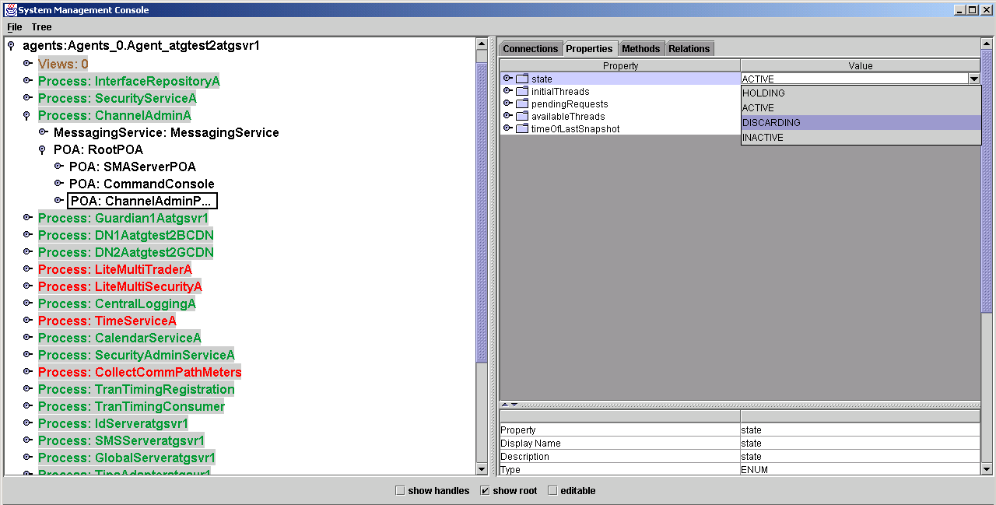

Double click DISCARDING
The value of state will change to DISCARDING and the process will be in Slave mode.

Transition a process to Master : Using the ChannelAdminA an example

Expand the ChannelAdminA process by clicking on the + to the left of the process node.
Find the POA:RootPOA node and expand it.
Click on ChannelAdminPOA
Change to the properties tab.
Click on the current value for state
NOTE: The value of state will be DISCARDING. If it is ACTIVE the process is already “Master”
After clicking on state, a drop arrow will appear to the far right

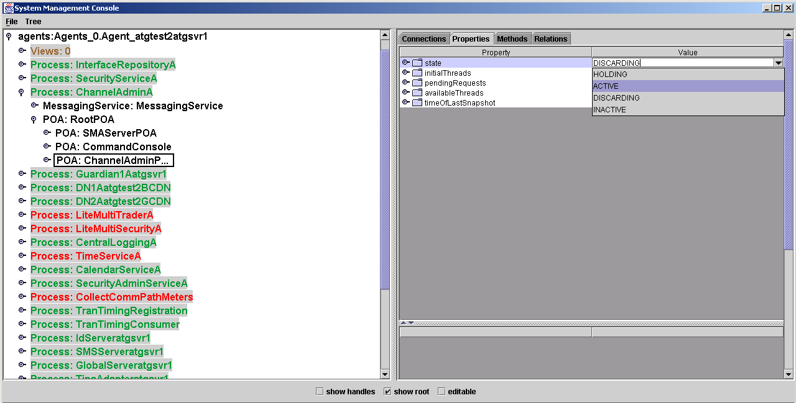

Double click ACTIVE
The value of state will change to ACTIVE and the process will be in Master mode.

Appendix C

Enable SysManAgent Mbean Locator

From the SysMan Console

Click on the agent node. The Agent process is the process preceded by Agent:
Select the properties Tab
If the MbeanLocatorStatus is Instantiated
Select the Methods tab
Invoke the startMBeanLocator command
Select the properties Tab
The MbeanLocatorStatus should change to Running – contact support if it does not

Appendix D

Initial Console Startup

Start the SysMan Console via SysMan Console Procedures

The initial console screen should look like the following:

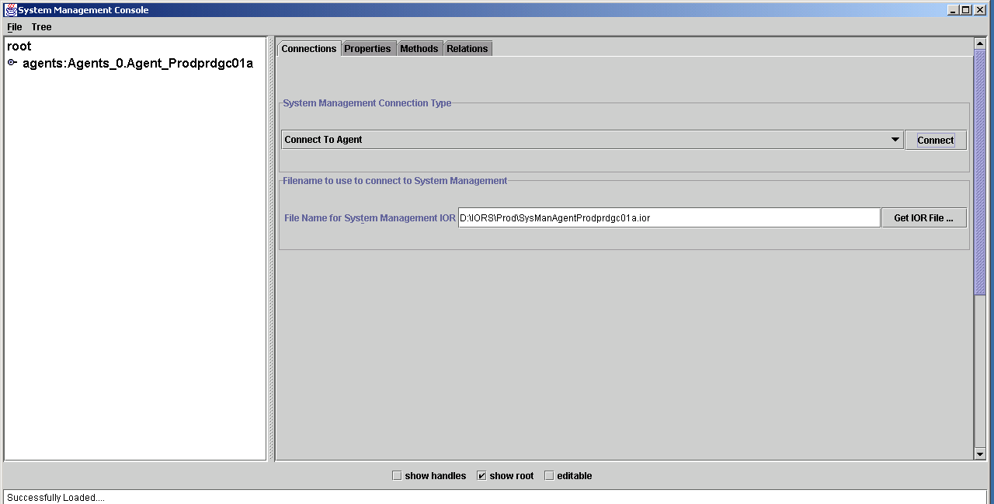

Double click the agents node to load the Views and the processes for this agent.

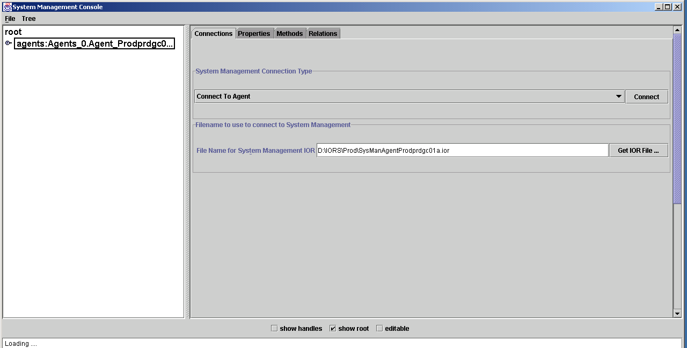

When complete the screen should look like this.

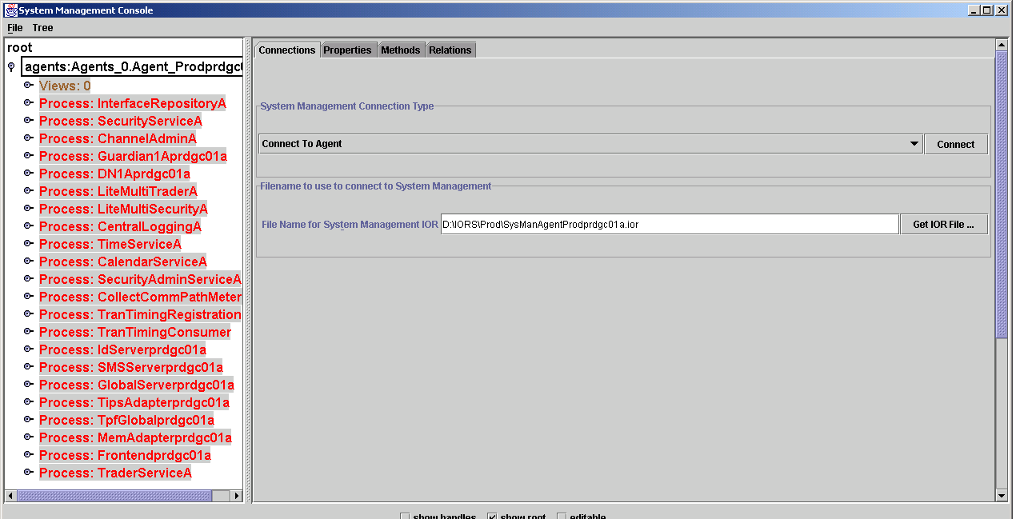

Next expand the Views node by double clicking on it.

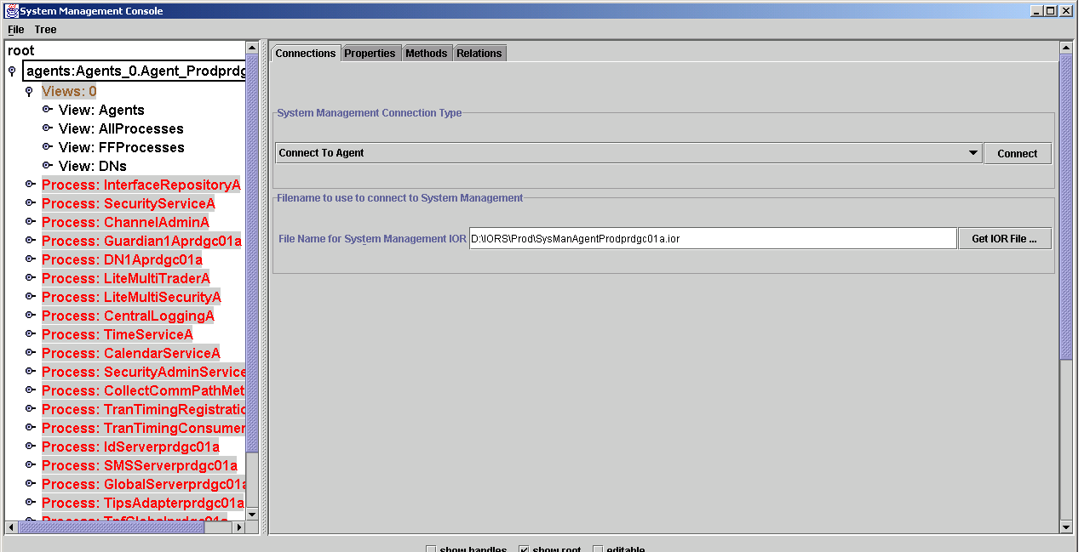

Expand the Agents by double clicking.

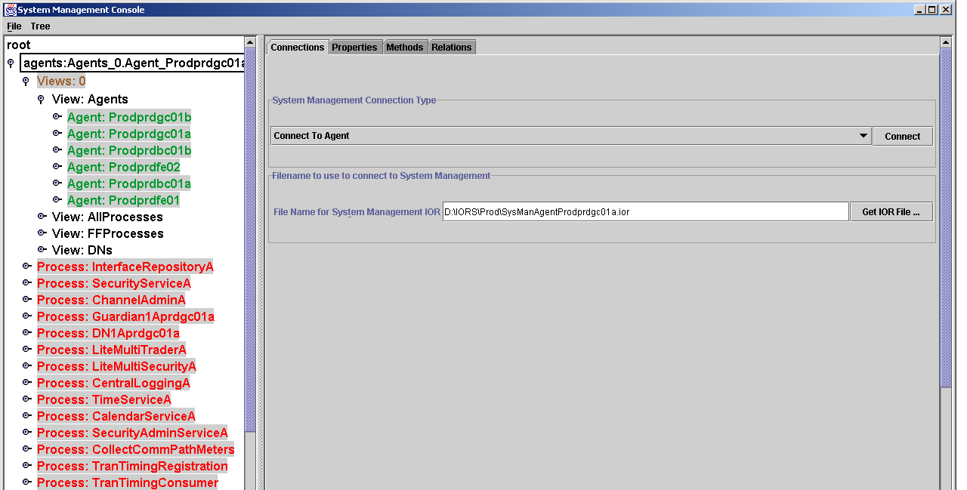

What is now displayed are all the agent process currently running in the complex. Each agent is responsible for starting stopping and monitoring a server.

Appendix E

Starting Processes from the SysMan Console

Double click on the agent for the server you want to start

NOTE-Expanding the agent will fail if its MbeanLocatorStatus in not Running. See Apendix .. for starting the MbeanLocator

Select the process by single clicking it
Select the methods tab in the window to its right
Select the Startup method
Right click the Startup method
Click on the Invoke box

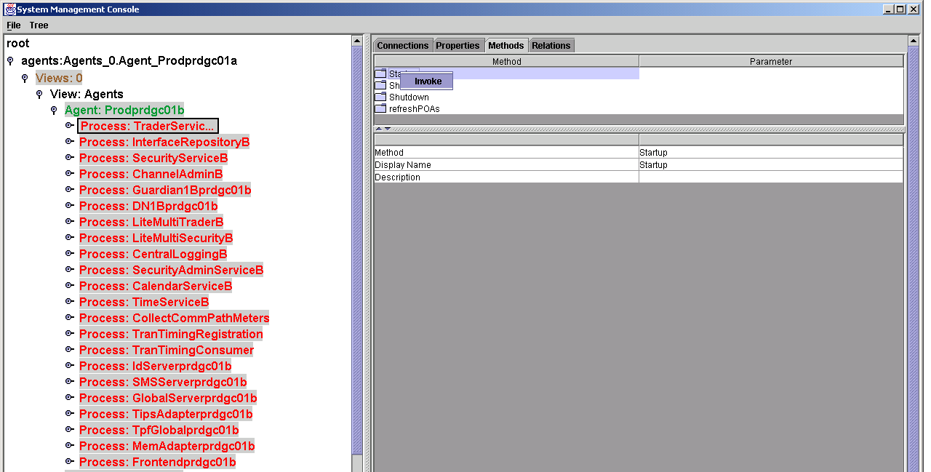

The process will turn Yellow to indicate it is starting

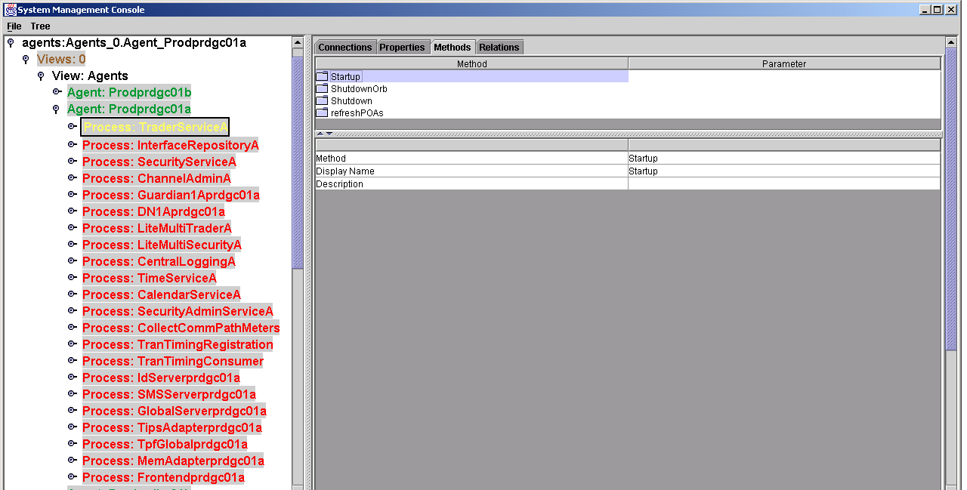

The process will turn Green indicating it is running.

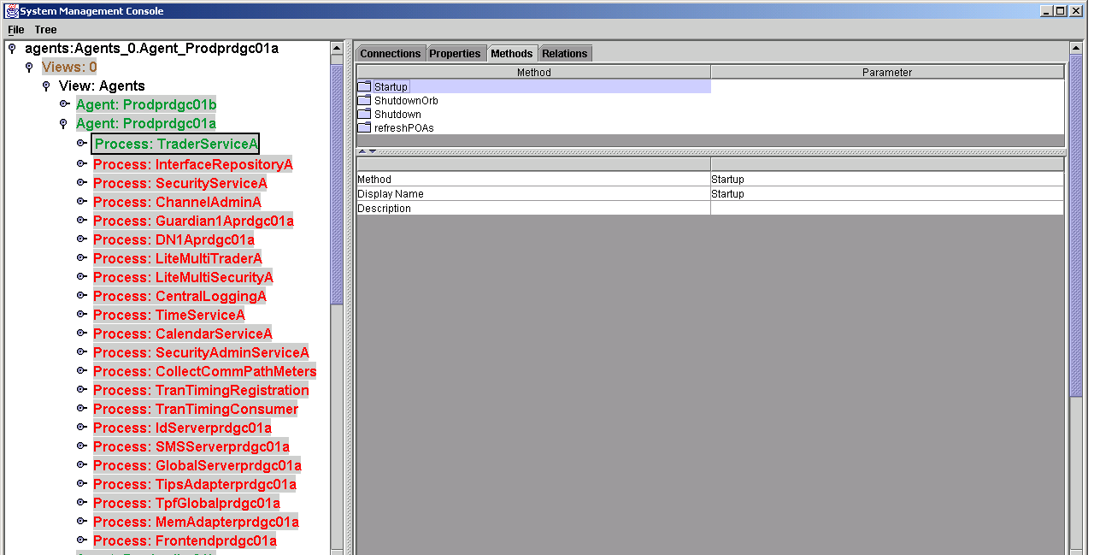

Appendix F

Shutting Down a Server

If you are absolutely sure that a server process should be stopped, then execute

ar server_name –f “GlobalFoundationFramework.FoundationFramework(SMSServer).shutdownCommand”

(where server_name is the name of the process, for example “TpfAdapter”)

Wait for a minute or two, then use the “chk” command described in the “Check System Status” section to verify that the process is gone. If the process appears to remain alive, then contact server support personnel.

